Guía3. Informe final Proyecto APT
Asignatura Capstone

1. Final APT Project Report
The purpose of this report is to describe the most relevant aspects of your APT Project. It is important that you justify the decisions you had to make throughout the process.

Below, you will find several fields that you must complete with the requested information, which provide a summary of your APT Project and its main results.

Project Name | “SeniorInteract”
Performance Area(s) | During the development of the SeniorInteract project, several performance areas from the curriculum were addressed, including:  Software Development, through the construction of a modular web platform using modern technologies such as Next.js and Supabase.  Databases, through the design and implementation of queries, reports, and relational data management.  IT Project Management, applying planning methodologies (Gantt Chart, WBS, project charter) and progress control.  Software Quality and Assurance, through functional testing, user testing, and accessibility validation.  UX/UI and Human–Computer Interaction, ensuring interfaces are friendly and accessible for older adults.  Security and Networks, guaranteeing secure authentication, access control, and encrypted communication via HTTPS and WebRTC.  Cloud Computing, with integration of external services such as Supabase (DB/Auth), Daily.co (video calls), and Cloudinary (media storage)
Competencies | Develop secure and high-quality software solutions, applying development methodologies and the software life cycle.  Design and implement relational databases, creating queries, reports, and routines that support system requirements.  Apply software analysis and design techniques to gather requirements, model use cases, and document the solution.  Perform tests and ensure software quality, verifying both functional and non-functional requirements.  Design usable and accessible user interfaces, considering Human–Computer Interaction (HCI) and accessibility principles for older adults.  Manage IT projects as a team, applying planning tools (project charter, WBS, Gantt chart, milestones).  Integrate cloud services and communication protocols, ensuring connectivity and scalability in the platform.  Demonstrate social responsibility and ethical commitment by developing an inclusive project that promotes digital participation for older adults.

Contenidos del informe final
1. Relevance of the APT Project | - The SeniorInteract project aimed to address a social and technological issue of significant importance: the growing digital divide affecting older adults in Chile. This population, with lower access to and mastery of technological tools, often becomes excluded from communication, entertainment, and social participation processes, increasing the risk of isolation, reduced cognitive activity, and weakened community ties.  - The relevance of this topic to the field of Computer Engineering is direct. Today’s industry requires professionals to develop inclusive, accessible, and user-centered solutions—especially for vulnerable groups who need adapted interfaces and simplified user experiences. Designing and implementing accessible digital platforms is a technical and social challenge that every computer engineer should be able to address through development methodologies, UX/UI, and user-oriented quality testing.  - The project was situated in the Municipality of Santiago, due to its high density of older adults and the identified need for tools that facilitate digital integration. This urban area features diverse populations with varying levels of digital literacy and technological access, making it an ideal setting for a technological inclusion pilot.  - The situation addressed mainly affects older adults, who face difficulties participating in social activities in person and also encounter barriers when trying to use conventional technological platforms. It also indirectly impacts social workers, municipalities, family members, and caregivers seeking effective tools to support the participation, autonomy, and emotional well-being of older adults.  - The value contributed by the APT Project was the creation of a functional and accessible digital platform that:  - facilitates communication between older adults through chat and video calls,  - promotes cognitive stimulation through adapted games,  - improves digital autonomy through a simple and accessible interface,  - provides a safe space for virtual interaction, and  - offers a scalable solution that can be implemented in other municipalities or institutions.  - Professionally, the project provides real and applicable value, addressing a relevant national need and demonstrating how Computer Engineering can produce inclusive technologies that contribute to social well-being. It also showcases key graduation-profile competencies such as software development, accessible UX/UI, software quality, and project management.
2. Objectives | General Objective  Develop an accessible and easy-to-use web platform that promotes digital and social inclusion among older adults, allowing them to communicate, participate in recreational and cognitive activities, and stay connected through tools adapted to their needs.  Specific Objectives  Design a simple and accessible interface considering usability principles for older adults (legible typography, intuitive navigation, appropriate colors, and visible buttons).  Implement a communication module enabling real-time chat and secure video calls.  Develop cognitive games and digital activities aimed at stimulating memory, attention, and cognitive abilities.  Integrate a user and role management system to allow administrators to register, modify, and supervise profiles, activities, and reports.  Incorporate security measures such as authentication, access control, and proper handling of sensitive data.  Apply quality and accessibility testing, verifying that each module functions correctly and is understandable for users with low digital literacy.  Implement a pilot environment for a specific institution or municipality (Santiago Centro) to validate the system in a real or simulated context.
3. Methodology | The SeniorInteract APT Project was developed using a phase-based development methodology, structured sequentially to plan and execute each stage clearly and efficiently. The methodology was divided into five main phases: Planning, Design, Development, Testing and QA, and Implementation and Closure.  Each phase included specific deliverables that had to be completed before moving on to the next one, ensuring a controlled and organized workflow aligned with the project goals.  Phases and Procedures  1. Planning Phase  Activities:  Definition of project scope  Gathering general and specific requirements  Creation of the Project Charter  Identification of team roles (Project Manager, Analyst, Programmer, DBA, QA, Designer)  Development of the Gantt Chart, WBS, and milestones  Result: A clear roadmap and structured timeline for development.  2. Design Phase  Activities:  Database design and relational model  UML diagrams:  Use Case Diagram  Class Diagram  Sequence Diagrams (as needed)  Interface design (layout, colors, fonts, accessibility)  Documentation of functional and non-functional requirements (SRS)  Result: A fully conceptualized blueprint of the solution.  3. Development Phase  Activities:  User authentication and login system  Real-time chat module  Video call module  Cognitive games for older adults  Administrative panel for managing users and roles  Integration of external services (Supabase, Daily.co, Cloudinary)  Result: A working functional version of the platform.  4. Testing and QA Phase  Activities:  Unit testing  Functional end-to-end testing  Accessibility validation  Internal testing with simulated older-adult users  Bug logs and corrections  Result: A stable and usable platform.  5. Implementation and Closure Phase  Activities:  Creation of the User Manual  Preparation for deployment  Review of goal completion  Delivery of all final documentation  Result: A complete, documented, and ready-to-use solution.  Relevance of the Methodology  The phase-based methodology was appropriate because:  It maintained clear control over progress  It organized the team by assigning tasks per phase  It favored documentation, essential in academic and professional settings  It improved final quality through a full dedicated testing phase  It reduced risk by identifying issues early in design
4. Development | A phase-based methodology allowed the team to move in a structured and sequential way. Below are the stages:  Phase 1: Planning  Problem identification  Requirements gathering  Project Charter  WBS  Gantt Chart  Team organization  Result: Clear project definition and roadmap.  Phase 2: Design  Database model  UML diagrams  Accessible UI design  System architecture definition  Result: A complete system vision before coding.  Phase 3: Development  Authentication  Chat module  Video calling  Cognitive games  Administration panel  External service integration  Result: Functional platform prototype.  Phase 4: Testing and QA  Unit tests  Functional tests  Accessibility tests  User simulations  Bug fixing  Result: Improved stability and usability.  Phase 5: Implementation and Closure  User manual  Presentation environment  UI adjustments  Final documentation  Result: Platform ready for use or demonstration.  Facilitators  Clear methodology  Defined team roles  Modern tools (Next.js, Supabase, Cloudinary, Daily.co)  Strong documentation  Good communication  Continuous feedback  Difficulties  Complex database relationships  Integration issues between modules  Time constraints  Learning curve with external APIs  Repeated UI corrections for accessibility  Errors found during testing  Adjustments  Reprioritization of core features  Simplification of secondary tasks  Database restructuring  Redesign of UI components  Increased QA time  Diagram revisions
5. Evidence | 1. Planning  Project Charter  WBS  Gantt Chart  Requirements  2. Design  Database model  UML diagrams  UI prototypes  SRS  3. Development  Screenshots of modules  Source code  4. Testing and QA  Test Matrix  Bug logs  Accessibility checks  5. Implementation  User Manual  Final presentation  Repository version  5.2 Version Control  Each project document was version-controlled to maintain traceability and organization.  5.3 Project Repository  All source code, documentation, and assets are stored in:  GitHub Repository:  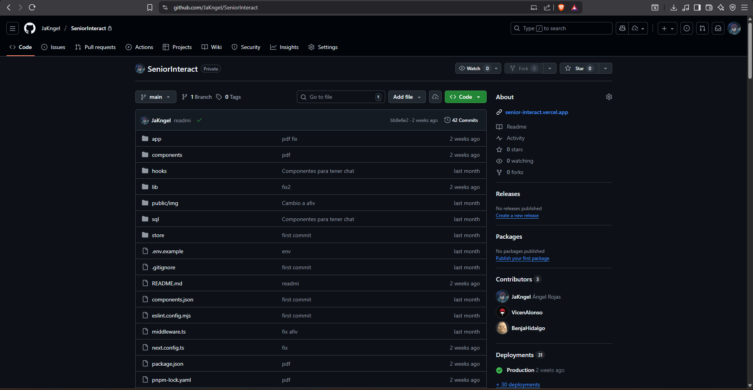  Includes:  Full system code  Documentation versioning  Project releases  Commit history
6. Professional Interests and Projections | The SeniorInteract APT Project allowed us to deepen and clarify our professional interests in Computer Engineering. From the beginning we were interested in software development, UX/UI, project management, and modern technologies. As each project phase progressed, these interests became more specific and meaningful.  Working on a solution for older adults highlighted the importance of building inclusive and accessible technologies. This encouraged us to explore digital accessibility, user-centered design, and usability evaluation methodologies. By addressing real problems and needs, we gained a clearer understanding of how technology impacts society when it is designed properly.  Modules like video calls, real-time chat, cognitive games, and an admin panel confirmed our interest in backend and frontend development, as well as API integration and cloud services. Building a stable platform strengthened our interest in software architecture, information security, and database design.  Strengthened Interests  Full Stack Development  UX/UI and accessibility  Databases and optimization  Cloud services and API integration  Project management  Quality Assurance  Each team member grew in skills associated with their assigned role, expanding their understanding of the different areas within computer engineering.  Career Projection After the Project  After completing the APT Project, our career goals became clearer. We plan to pursue:  Software development roles (Frontend, Backend, Full Stack)  UX/UI with inclusive design focus  Database administration  QA and testing  IT project management  Overall Team Projection  We believe the project prepared us to:  Join development teams  Participate in technological and social innovation projects  Specialize in technical areas  Continue professional studies and certifications  The APT Project not only demonstrated our competencies but also helped refine and guide our long-term professional goals.

